* Support Vector Machine (SVM) is a supervised machine learning algorithm which can be used for both classification or regression challenges.
* it is mostly used in classification problems.
* In the SVM algorithm, we plot each data item as a point in n-dimensional space (where n is number of features you have) with the value of each feature being the value of a particular coordinate. Then, we perform classification by finding the hyper-plane that differentiates the two classes very well.
* 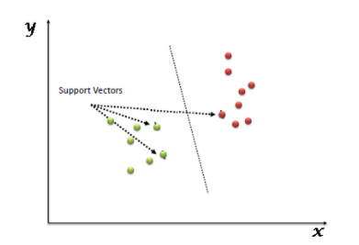
* the process of segregating the two classes with a hyper-plane.
* **Identify the right hyper-plane (Scenario-1):** Here, we have three hyper-planes (A, B and C). Now, identify the right hyper-plane to classify star and circle.
* 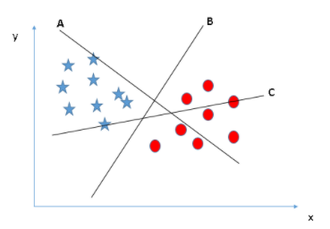
* You need to remember a thumb rule to identify the right hyper-plane: “Select the hyper-plane which segregates the two classes better”. In this scenario, hyper-plane “B” has excellently performed this job.
* **dentify the right hyper-plane (Scenario-2):**Here, we have three hyper-planes (A, B and C) and all are segregating the classes well. Now, How can we identify the right hyper-plane?
* 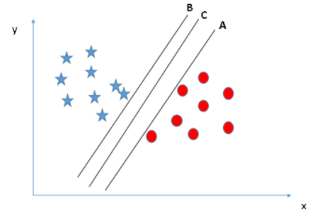
* Here, maximizing the distances between nearest data point (either class) and hyper-plane will help us to decide the right hyper-plane. This distance is called as **Margin**. Let’s look at the below snapshot:
* 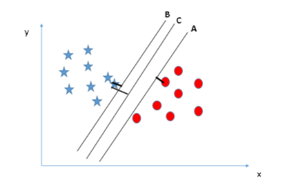
* the margin for hyper-plane C is high as compared to both A and B. Hence, we name the right hyper-plane as C. Another lightning reason for selecting the hyper-plane with higher margin is robustness. If we select a hyper-plane having low margin then there is high chance of miss-classification.
* **Identify the right hyper-plane (Scenario-3):Hint: Use the rules as discussed in previous section to identify the right hyper-plane**
* 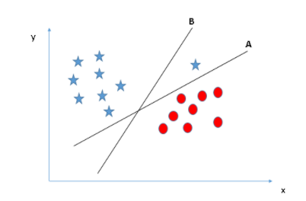
* SVM selects the hyper-plane which classifies the classes accurately prior to maximizing margin. Here, hyper-plane B has a classification error and A has classified all correctly. Therefore, the right hyper-plane is **A.**
* **Can we classify two classes (Scenario-4)?:**Below, I am unable to segregate the two classes using a straight line, as one of the stars lies in the territory of other(circle) class as an outlier.
* 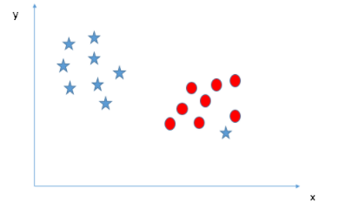
* one star at other end is like an outlier for star class. The SVM algorithm has a feature to ignore outliers and find the hyper-plane that has the maximum margin. Hence, we can say, SVM classification is robust to outliers.
* 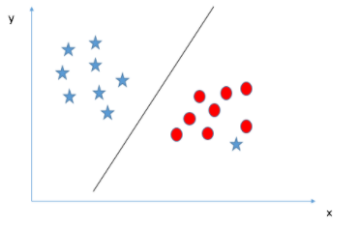
* **Find the hyper-plane to segregate to classes (Scenario-5):**In the scenario below, we can’t have linear hyper-plane between the two classes, so how does SVM classify these two classes? Till now, we have only looked at the linear hyper-plane.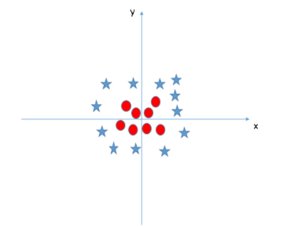
* SVM can solve this problem. Easily! It solves this problem by introducing additional feature. Here, we will add a new feature z=x^2+y^2. Now, let’s plot the data points on axis x and z:
* 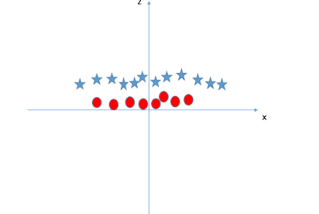

In above plot, points to consider are:

* All values for z would be positive always because z is the squared sum of both x and y
* In the original plot, red circles appear close to the origin of x and y axes, leading to lower value of z and star relatively away from the origin result to higher value of z.

In the SVM classifier, it is easy to have a linear hyper-plane between these two classes. But, another burning question which arises is, should we need to add this feature manually to have a hyper-plane. No, the SVM  algorithm has a technique called the [**kernel**](https://en.wikipedia.org/wiki/Kernel_method)**trick**.

It uses a technique called the kernel trick to transform your data and then based on these transformations it finds an optimal boundary between the possible outputs.

Advantage and disadvantage

It uses a subset of training points in the decision function which makes it memory efficient and is highly effective in high dimensional spaces.

The only disadvantage with the support vector machine is that the algorithm does not directly provide probability estimates.